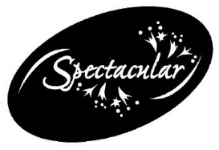
Spectacular Bourbon Basket Raffle
Tickets are $75 a Piece
Only 100 tickets will be Sold
Valued at over $800
13 Bourbons, Angel’s Envy Honey, Tumbler Glasses all Displayed in a Half Bourbon Barrel
Donated by Principal Rohr and School Parents Matt Ryan & Tim Marks
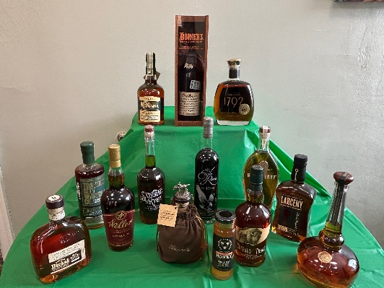
- Willet Pot Still Reserve
- Bookers – 2023-2 “Apprentice Batch”
- Weller Antique 107
- Angel’s Envy Private Selection 2022 Barrel Proof
- Sazerac Rye
- Henry McKenna Single Barrel Bottled in Bond 10 year
- George Dickel Hand Selected 9-year Small Batch
- Traverse City Straight Rye Barrel Proof Single Barrel
- Larceny Barrel Proof
- Eagle Rare
- Buffalo Trace
- Blanton’s Single Barrel
- 1792 Full Proof Single Barrel Select
- 2 St. Sebastian Tumbler Glasses
- Displayed in a Thirsty Dog Half Bourbon Barrel (priceless)
